# Character Creation Manager for Dungeons and Dragons, 5th Edition

# Team Members:

1. Landon Grady - 900854523
2. Alexander Majors - 900855484

# Document Revision History:

* 3/15
  + Added updated screenshots of currently implemented activities:
    - characterList.java
    - createCharacter.java
    - expandCharacter.java
  + Added screenshots of implemented database used to store and read data
  + Possible features based on feedback:
    - character randomizer
    - Create custom backgrounds, race, or class

# Project Description:

* This app will function as digital character sheet for the tabletop pen and paper game Dungeons and Dragons. This includes:
  + Creating new characters and storing previously made characters
  + Assigning stats for each created character such as strength, dexterity, wisdom, etc.
  + Ability to edit a created character
  + Ability to roll for skills with a simple button click and display the result to the user
  + Allow the user to customise their character by adding a portrait and assign UI colors to the sheet
* The user demographic of this app will be people who play Dungeons and Dragons 5 Edition and desire an alternative to the current pen and paper system. The advantages of using this app over the traditional method includes:
  + Ability to conveniently carry all created characters on their person via smartphone
  + Skill checks and attack rolls, which typically require user calculation and consume precious time, can be automated through the use of button clicks and background arithmetic
  + The user no longer requires the use of physical dice to roll for skills, combat, etc. Instead, the app will the corresponding die (4-sided, 6-sided, 8-sided, 10-sided, 12-sided, and 20-sided) when prompted
* Key features include:
  + Character creation:
    - User will be able to input core abilities manually or randomly roll their stats
    - User will be able to pick their character’s race, background, and class with a drop down list
    - User will be able to pick skill proficiencies via a checkbox
    - As the character level changes, the sheet updates with the appropriate abilities corresponding with that classes level
  + Character storage:
    - Created saved characters will be display in a list displaying their name, race, class, and background
    - User is able to pick from this list to edit or roll using their stats
  + Dice automation:
    - User will be able to roll a dice when selecting a skill and displayed the correct output
    - Will in combat, user will be able to roll a dice to hit and immediately prompted to roll damage should the hit connect with an enemy
* Possible implementation based on feedback during presentation:
  + Character randomizer:
    - Allow the user to generate a random character
  + Import custom race, background, or class
    - Allow the user to update the database with their personal race, background, or class by filling out a form and storing the creation within the database for future use.

# Task Distribution:

* A tentative plan on who will do which part of the project. It is better if each person documents how he/she will contribute in the project.
* Landon:
  + Create the layouts for each screens
  + Handle dice rolling for stats and combat
  + Handel character stats layout
* Alex
  + Create list of all standard 5th Edition classes, races, and background choosable by the user
  + Handle the character creation layout
  + Handle inventory layout (still deciding if this feature will be implemented)

# Design Plan:

* If you have thought through some parts of the design, like the User Interface, you can add over here. Hand-drawn sketch of the UI will suffice now.

Here’s a list of all the created characters with their name, class, race, and background displayed. Here, the user will be able to select a previously created character and edit their sheet or character an entirely new character. Next, is the screen for determining the how the stats will be laid out for the user.

Currently implemented activities:

**characterList.java**: Recyclerview for viewing all created characters

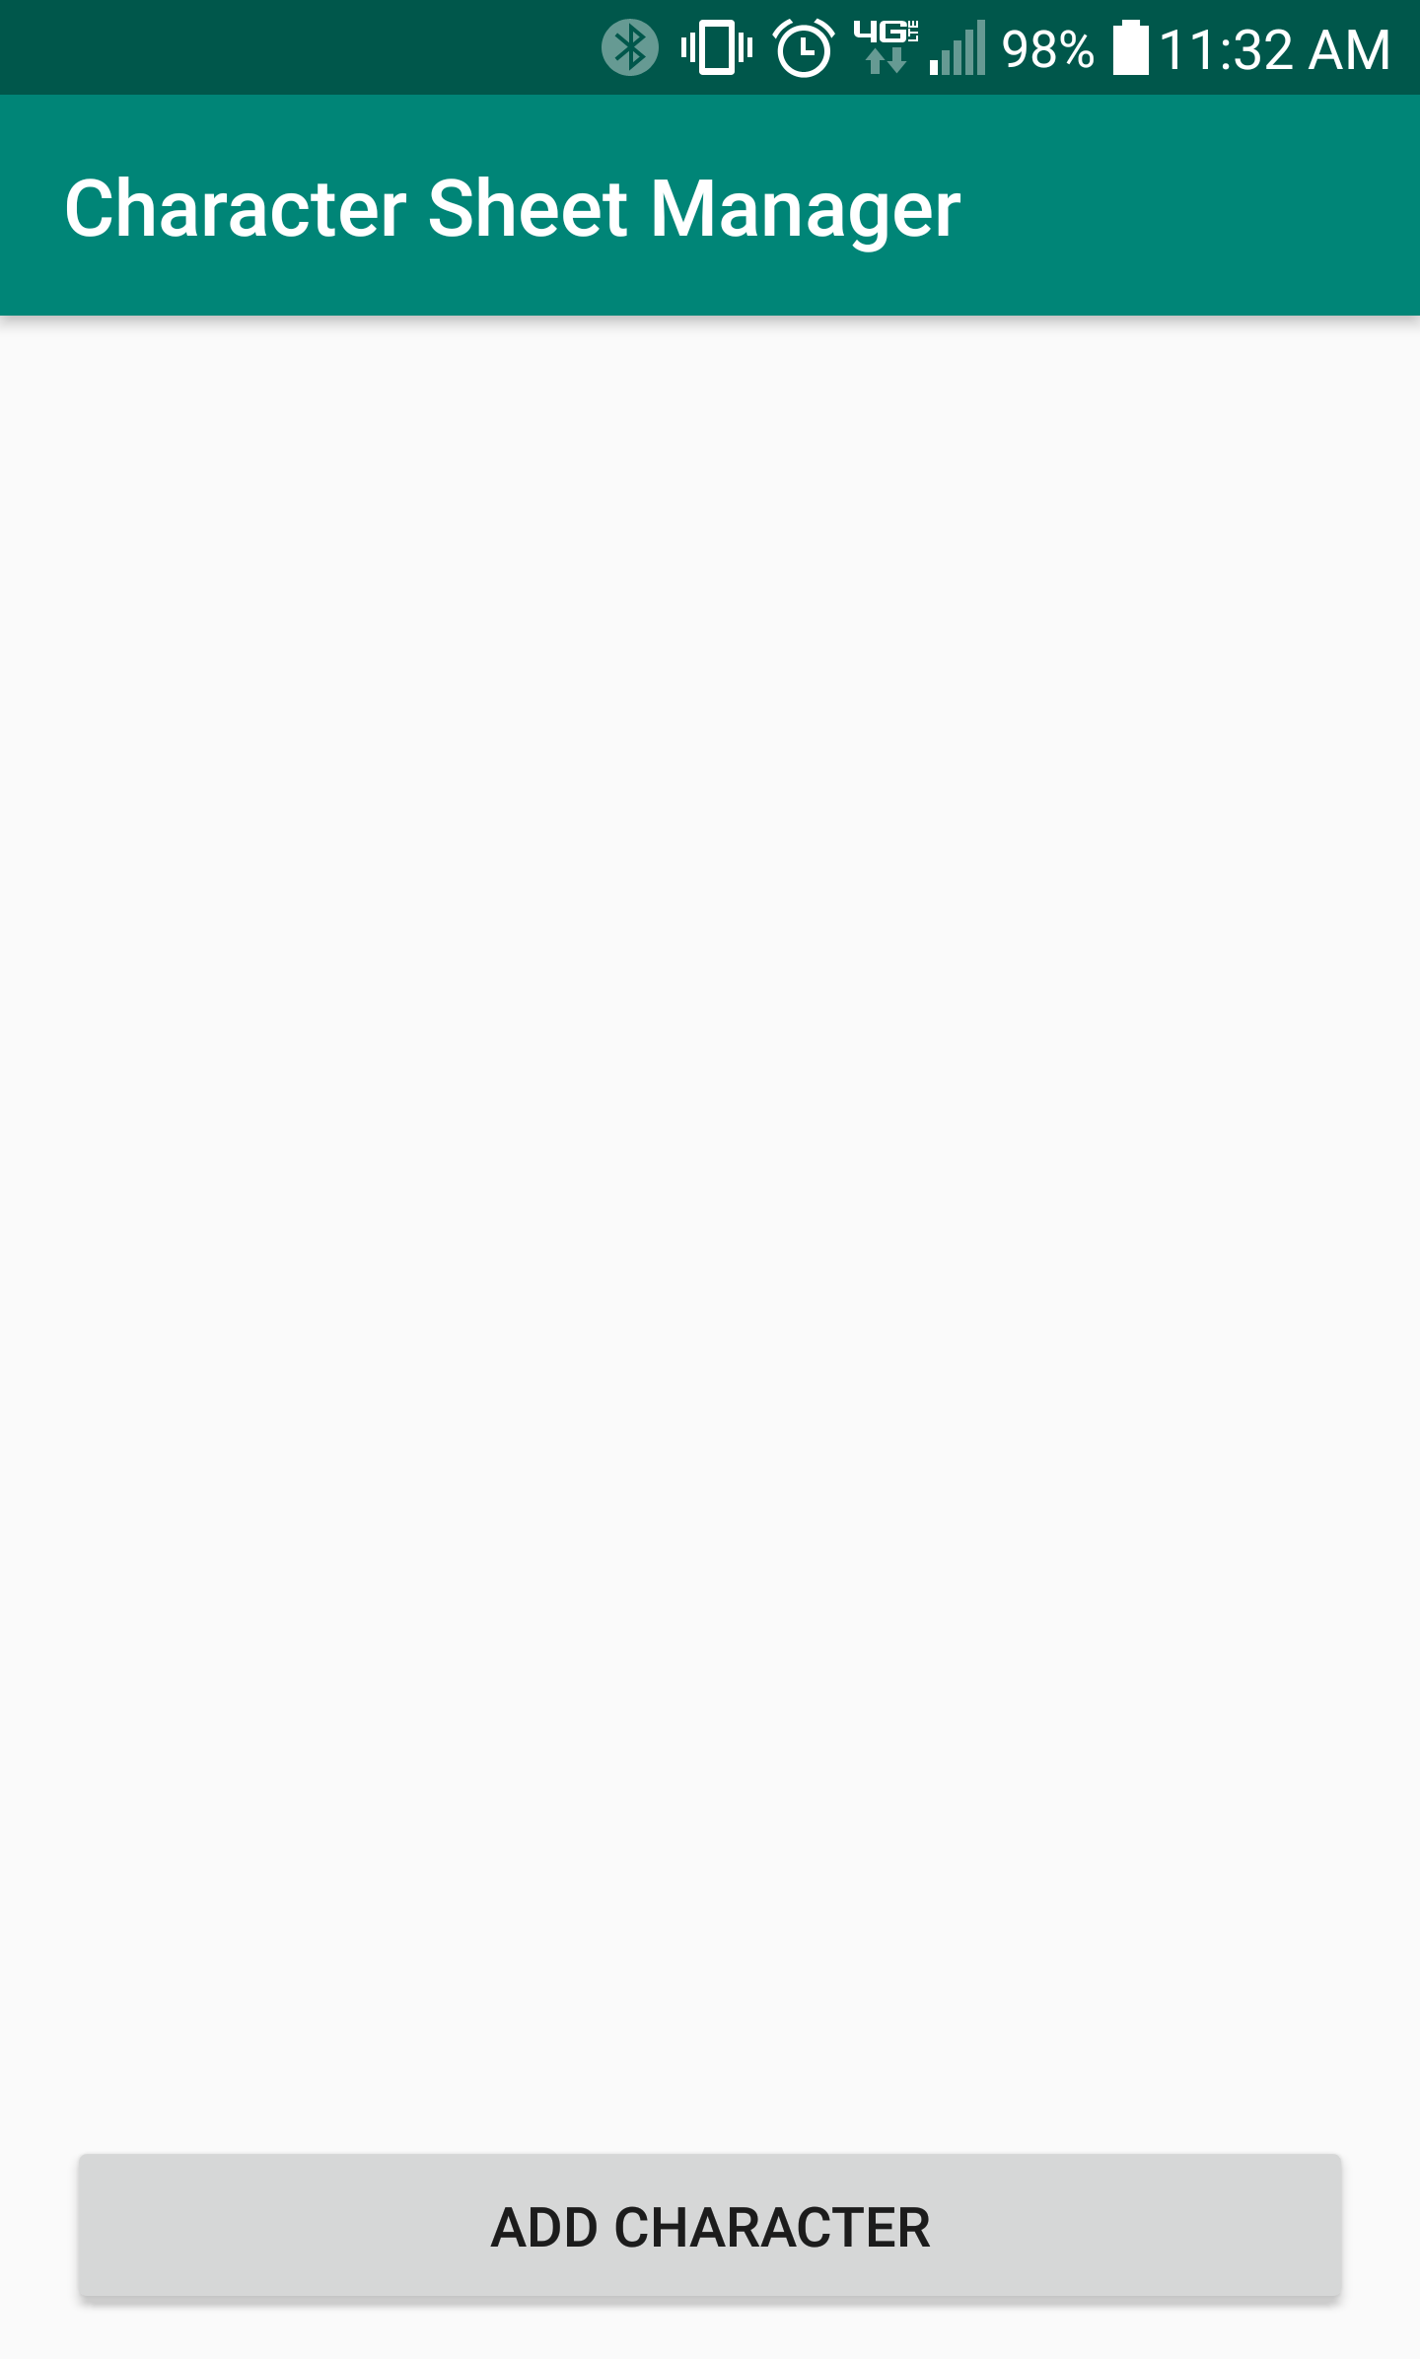

**createCharacter.java**: Activity for creating a new character via user inputs

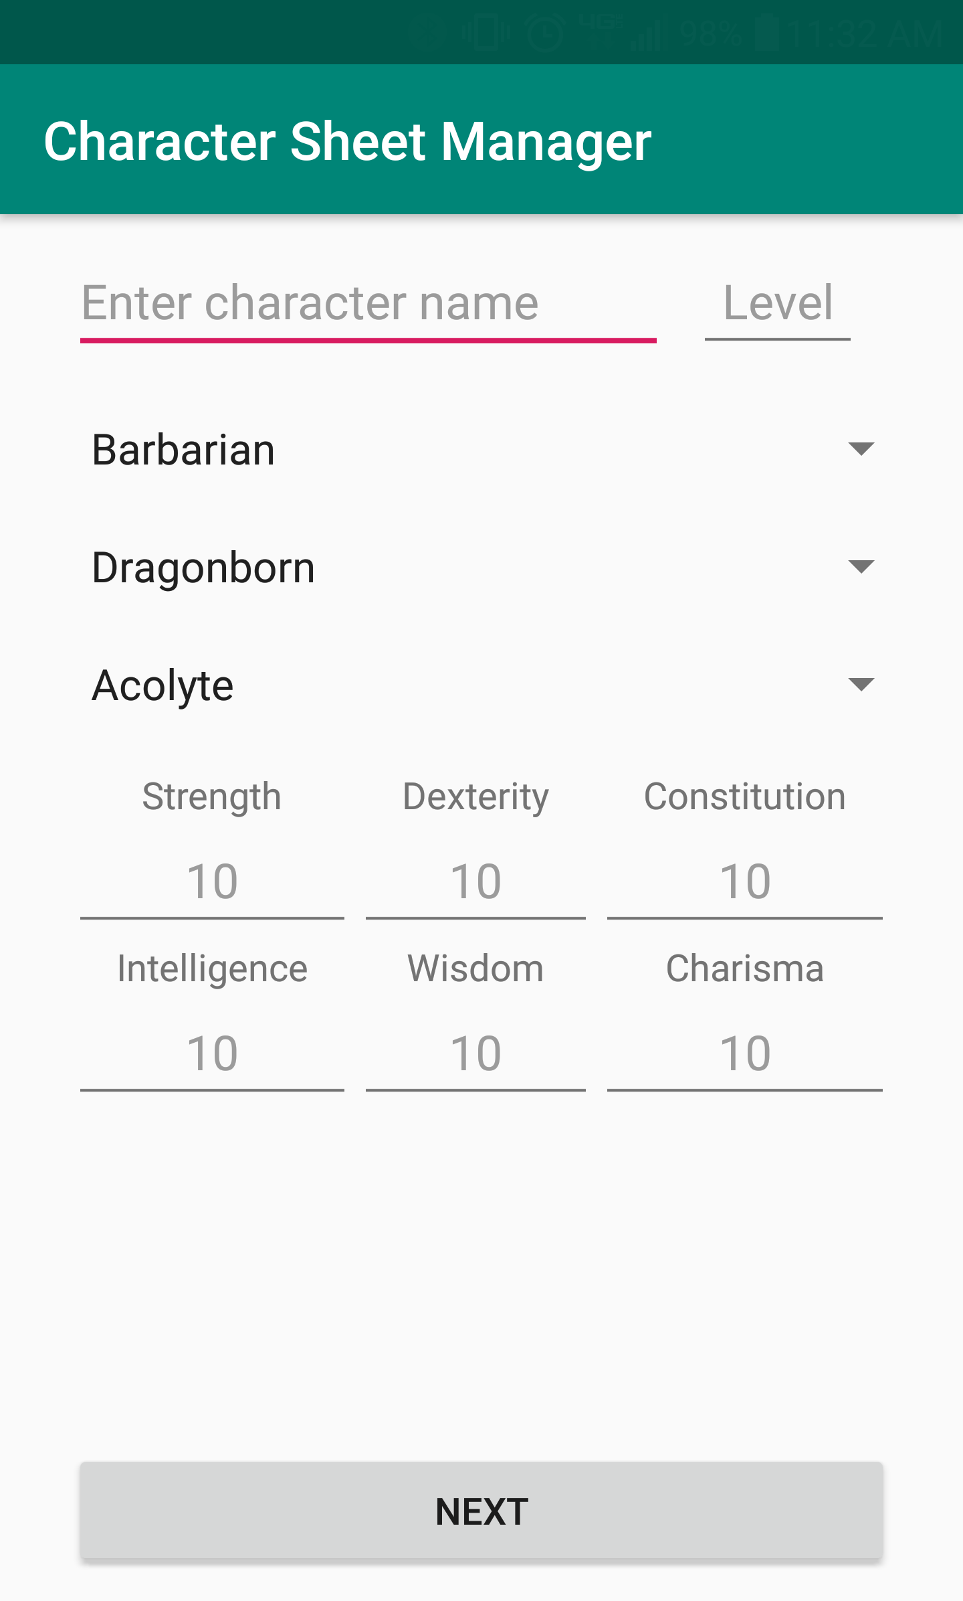

**expandCharatcer.java**: Activity for further expanding on created character based on the inputs of the previous activity:

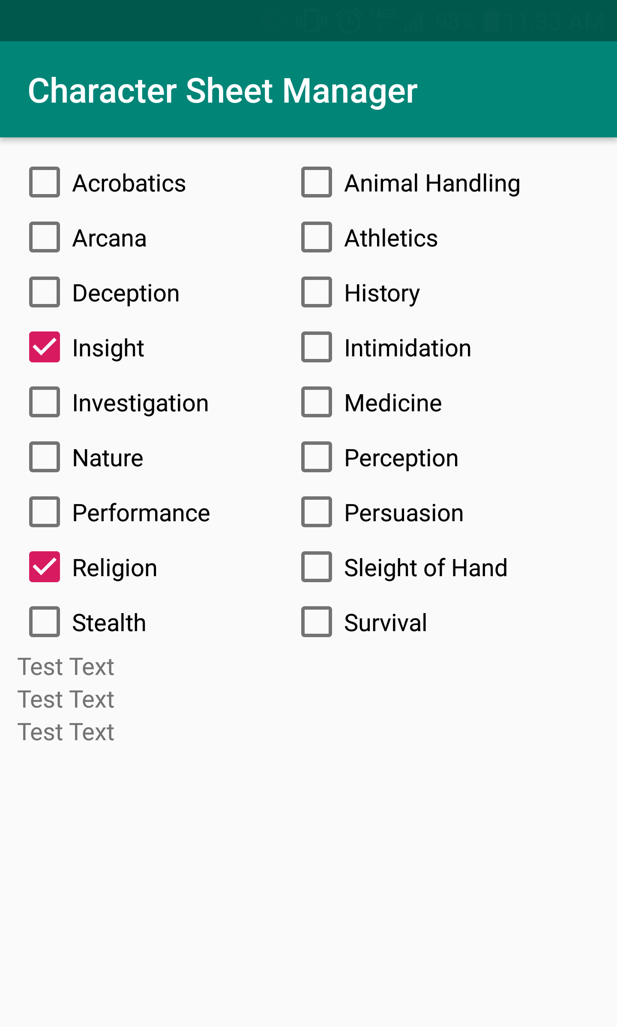

Overall database:

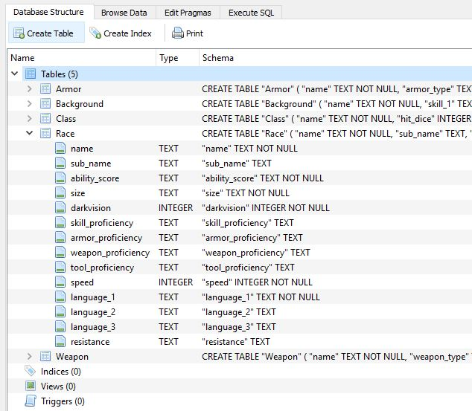

Example Background Table:

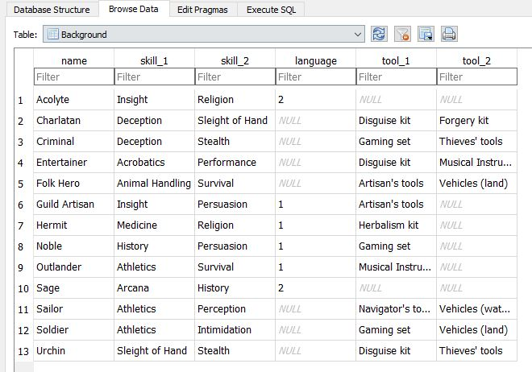

# Evaluation Plan:

* Character creation: allow a user to create and customize a character in line with 5th edition D&D standards.
* View created characters: allow the user to see a full list of all previously created characters. Included in this would the ability to edit and changes aspects of that created character.
* Roll dice: roll a simulated die that would facter in a characters stats into the roll so that the final number given would be accurate. Would also include the option to choose what action that this roll is for, so the correct stat is taken into account.
* Inventory management: allow the user to manage and handle a characters inventory. Would allow for the adding and removing of items from the inventory.

# Relevant Work:

Here I want you to look in Google Play and report what is the closest app in terms of features that you could find. Provide a URL to the app. You should mention how your app differs from the one you found.

The closest app to the one we wish to create is named Squire - Character Manager Pro:

(<https://play.google.com/store/apps/details?id=com.herd.squire&hl=en_US>)

The major difference between our app and Squire will most likely be our limitation of source material. In Squire, you have the ability to import different playable races, classes, and background from other source expansions. We will most likely limit ourselves to the standard 5th edition rules sets and classes as to not overwhelm ourselves later in the implementation of the project.

Squire also allows users to input custom races, backgrounds, and class not stemming from any official source while we will only provide the standard 5th edition options.